Name:
Date:
15.07 Picture Lab Worksheet
Directions: Make note of your responses to the following questions as you work through the activities and exercise in the lesson.
Activity 5 Questions
Question | Yes | No
- Is the method getPixels2D in the Picture.java class? |  | X
- Is the method getPixels2D in the SimplePicture.java class? | X
- Will the following code compile?  DigitalPicture p = new DigitalPicture(); |  | X
- Assuming a no-argument constructor exists for SimplePicture, will the following code compile?  DigitalPicture p = new SimplePicture(); | X
- Assuming a no-argument constructor exists for Picture, will the following code compile?  DigitalPicture p = new Picture(); | X
- Assuming a no-argument constructor exists for Picture, will the following code compile?  SimplePicture p = new Picture(); | X
- Assuming a no-argument constructor exists for SimplePicture, will the following code compile?  Picture p = new SimplePicture(); |  | X

Activity 5 Exercise Results

- Describe your method for keepOnly red, blue, or green.
I created the keepOnly blue method. The method did the same thing as the zeroBlue method, except instead of setting the blue of all pixels to 0, my method set the red and green of all pixels of 0. I started by getting the 2D array of pixels and then used for-each loops going through each Pixel Object to call setRed(0) and setGreen(0) on every pixel.
- For the negate method, paste your code related to calculating and setting the values for red, blue, and green.
pixelObj.setRed(255 - pixelObj.getRed());
pixelObj.setBlue(255 - pixelObj.getBlue());
pixelObj.setGreen(255 - pixelObj.getGreen());
- Paste a copy of the image that is the result of calling the grayscale.
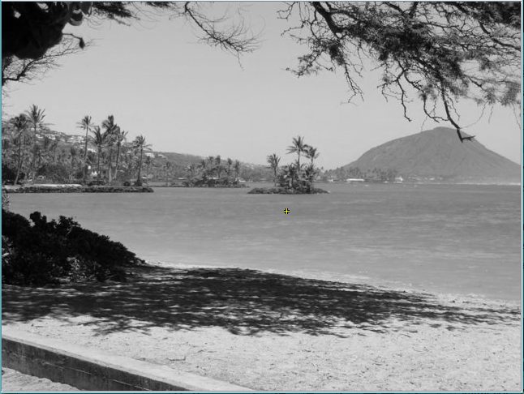

- For the method fixUnderwater, describe the algorithm you'd propose to accomplish the task.

You notice that the pixels of the fish usually have higher blue pixel values than green pixel values, whereas the background pixels usually have higher green pixel values than blue pixel values. As a result, an algorithm that sets the pixel color to red if the blue pixel value is greater than the green pixel value will make it easier to see fish.

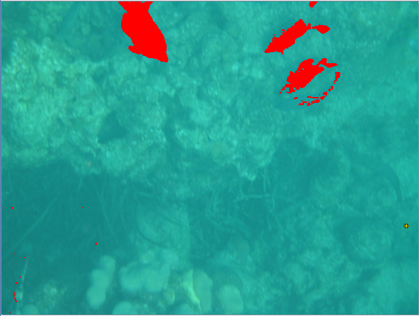

Activity 6 Exercise Results
- Paste the image that is the result of calling the method mirrorVerticalRightToLeft.

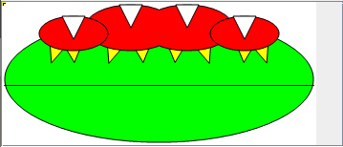
- Describe the algorithm for the method mirrorHorizontal works.
Use two nested for loops with the variable row going from 0 to height / 2 and the variable col going from 0 to width. Set topPixel equal to the pixel at the given row and col and bottomPixel equal to the pixel at the given row and the column, height – 1 – col. Finally, set the color of the bottomPixel equal to the color of the topPixel.
- Paste the image that is the result of calling the method mirrorHorizontalBotToTop.
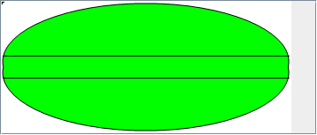

Activity 7 Questions
  - How many times would the body of this nested for loop execute? __90___
for(int row = 7; row < 17; row++)
for(int col = 6; col < 15; col++)
  - How many times would the body of this nested for loop execute? __112___
for(int row = 5; row <= 11; row++)
for(int col = 3; col <= 18; col++)

Activity 7 Exercise Results

- What value is displayed for count after the nested loop ends in the mirrorTemple method? __18410__
- Paste the image that is the result of calling the method mirrorArms.
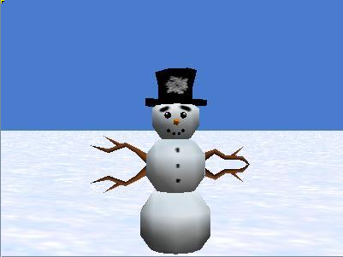
- Paste the image that is the result of calling the method mirrorGull.
